[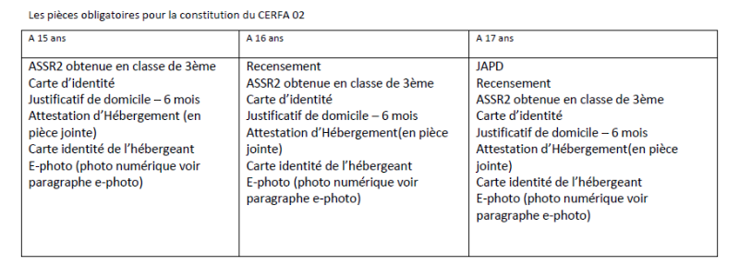](http://saintandeol.typepad.fr/.a/6a011570dd87f5970c01bb09f753a2970d-pi)